MINOR INJURY SERVICES IN ANGUS:
Mondays to Fridays 8am to 6pm
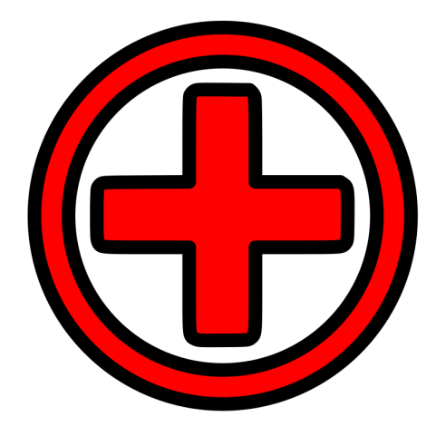
If you have a MINOR INJURY
between 8am and 6pm Monday to Friday and are registered in Edzell
please PHONE the Health Centre for advice.
If the problem is urgent and
you can’t get to Edzell quickly,
go straight to the nearest
Minor Injury Unit in Angus
– see below for details.
Minor Injury and Illness Services in Angus

Edzell Health Centre DD9 7TA
Open Monday to Friday 8am to 6pm
PLEASE PHONE FIRST FOR ADVICE
Saturday, Sunday, Public Holidays CLOSED

Brechin Health Centre DD9 7AN
Open Monday to Friday 9am to 4.30pm
Saturday, Sunday, Public Holidays CLOSED

Montrose: Links Health Centre DD10 8TY
Open Monday to Friday 9am to 4.30pm
Saturday, Sunday, Public Holidays CLOSED

Forfar: Whitehills DD8 3DY
Open Monday to Friday 9am to 4.30pm
Saturday, Sunday, Public Holidays 8am to 10pm

Arbroath Infirmary DD11 2AT
Open 24 hours, including weekends and Public Holidays

